## 1- General Information:

***The max height of the arm:***

**Half of the drive-train's length:**

75cm-80cm.

**What the intake will contain:**

- Genuino/Arduino MKR1000 Microcontroller.

- Arduino Nano. (to plug in the movement rev motors, or Arduino Mega as an alternative)

- Arduino MKR ENV Shield: Gives values of temperature, humidity, pressure and illuminance.

- ArduCam Mini Module Camera Shield 5MP Plus: Captures images of its surroundings and records footage. It can help in spotting activities that cause environmental instability.

- Adafruit MicroSD Card Breakout Board: Used to store data in a 32GB microSD card.

- High capacity Li-ion battery.

- Solar Panels: to charge the Li-ion battery. (allows photons, or particles of light, to knock electrons free from atoms, generating a flow of electricity.)

## 2- Design Process:

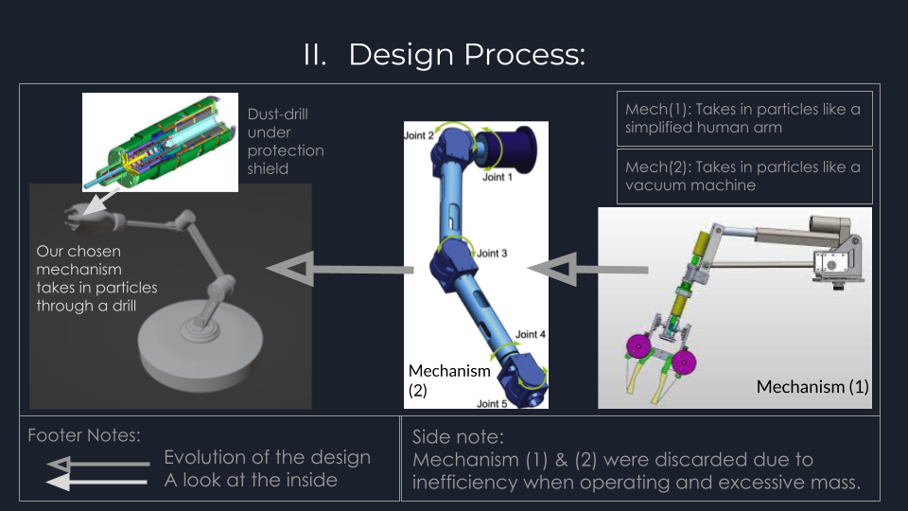

## 3- Detailed structure:

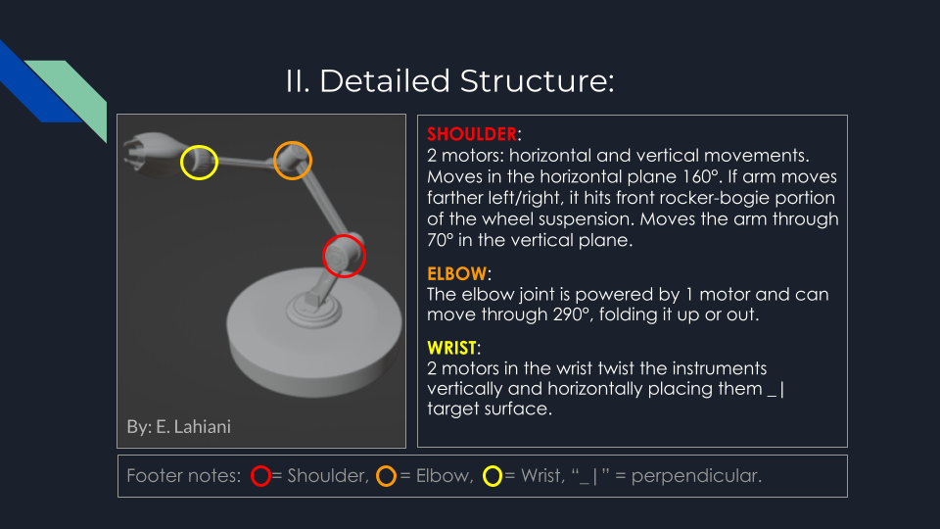

## 4- Final Product:

| Inside | Outside + 3d printed shield |
| --- | --- |
|  |  |

